Section 0 -Use GIT as local VCS. Steps to follow:

1. Create a directory ‘project_dir’ & cd to ‘project_dir’.

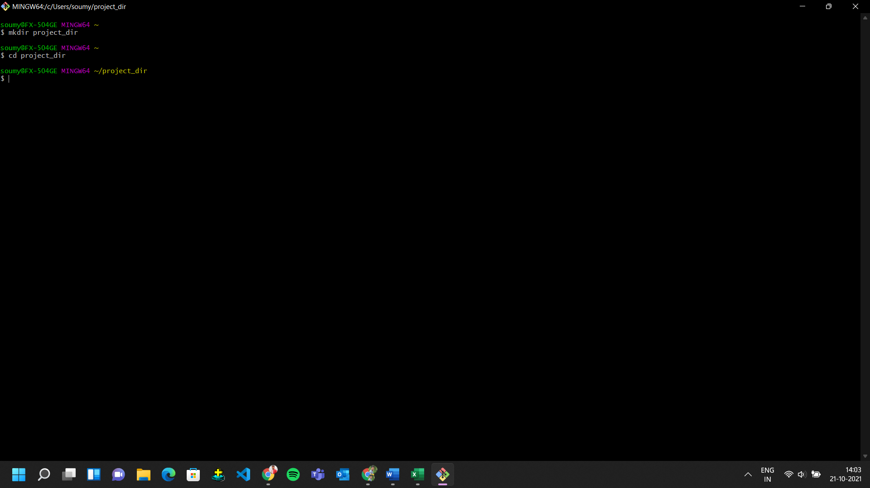

1. Initialize git version database. (git init)

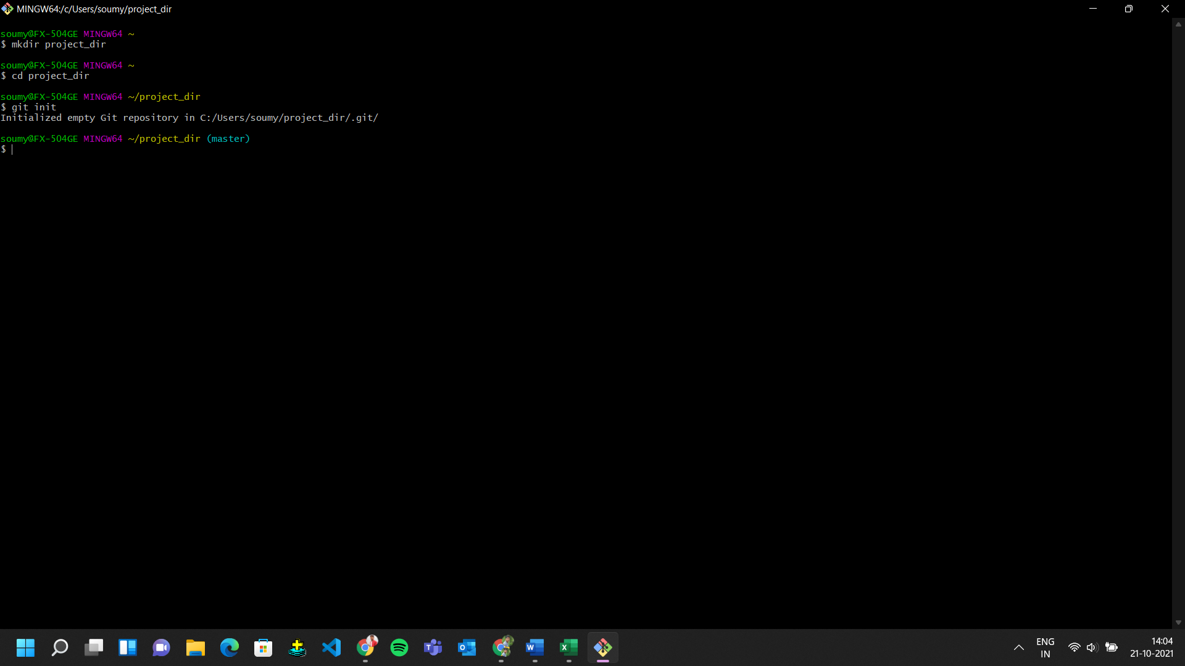

1. Create a new file index.html.

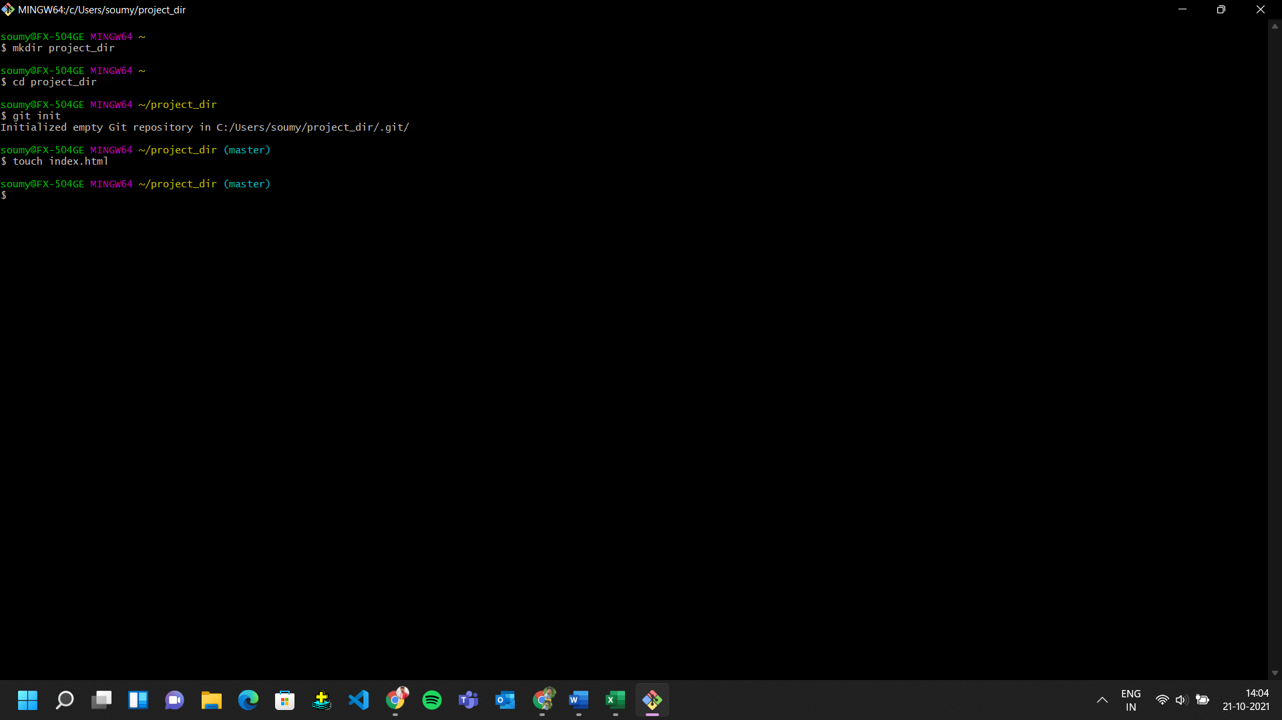

1. Check the git status. You should find index.html as untracked file.

1. A screenshot of a computer

   Description automatically generated with medium confidenceStage the index.html file.
2. Commit index.html

1. A screenshot of a computer

   Description automatically generated with medium confidenceA screenshot of a computer

   Description automatically generatedMake few changes in index.html & create a new file info.txt file.
2. Check git status. You should find index.html & info.txt as untracked files.

1. Configure GIT to ignore all txt files.

1. Again check the git status. You should find only index.html as untracked file.

1. Stage & commit index.html

1. Log all your comments so far.

1. Make some changes in index.html.

1. A screenshot of a computer

   Description automatically generated with medium confidenceRevert the change made in the previous step using git command.
2. A screenshot of a computer

   Description automatically generatedAgain change index.html.
3. Stage index.html
4. Revert back the last stage.
5. Rename ‘add’ command to ‘my-add’.

1. Using my_add command Stage index.html again & commit the changes.

1. Revert the last commit.

